|  |
| --- |
| Circle Language Spec: Commands |

## Active Clauses in a Command Reference in a Diagram

This article demonstrates a situation of command objects.

This article illustrates how active clauses in a command reference look in a diagram.

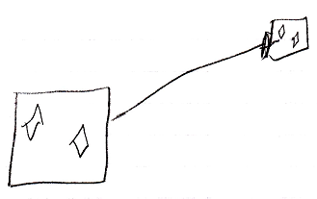

The large square on the left is a command reference. It is pointing out its target command definition with an object line, the solid line, targeting the square on the right, which is the command definition. The command reference on the left contains two active clauses, diamonds, that do not redirect their target. The target definition on the right also shows the diamonds inside of it. Both command reference and target definition both represent the same command object, so their contents are also the same, so they both show active clauses.

Either of the squares could have been replaced by a diamond, making the command symbol executable, rather than dormant.